Gaussian Derivation of Porbability:
$$P\left\{x^{'}<r<x^{''}\right\}=\frac{1}{\sqrt{2π}}\int_{t_{1}}^{t_{2}}{e^{-\frac{t^{2}}{2}}dt}$$

$$ϕ\left(x\right)=\frac{2}{\sqrt{2π}}\int_{0}^{x}{e^{-\frac{t^{2}}{2}}dt}$$

$$P\left\{x^{'}<r<x^{''}\right\}=\frac{1}{2}\left[ϕ\left(t_{2}\right)-ϕ\left(t_{1}\right)\right]$$

$$ϕ\left(t_{2}\right)=\frac{2}{\sqrt{2π}}\int_{0}^{t_{2}}{e^{\frac{{-t}^{2}}{2}}dt}$$

$$ϕ\left(t_{1}\right)=\frac{2}{\sqrt{2π}}\int_{0}^{t_{1}}{e^{\frac{t^{2}}{2}}dt}$$

$$ϕ\left(t_{2}\right)-ϕ\left(t_{1}\right)=\frac{2}{\sqrt{2π}}\left[\left(\int_{0}^{t_{2}}{e^{\frac{{-t}^{2}}{2}}dt}\right)-\left(\int_{0}^{t_{1}}{e^{\frac{t^{2}}{2}}dt}\right)\right]$$

$$\frac{1}{2}\left[ϕ\left(t_{2}\right)-ϕ\left(t_{1}\right)\right]=\frac{1}{\sqrt{2π}}\left[\left(\int_{0}^{t_{2}}{e^{\frac{{-t}^{2}}{2}}dt}\right)-\left(\int_{0}^{t_{1}}{e^{\frac{t^{2}}{2}}dt}\right)\right]$$

By Geometric argument:

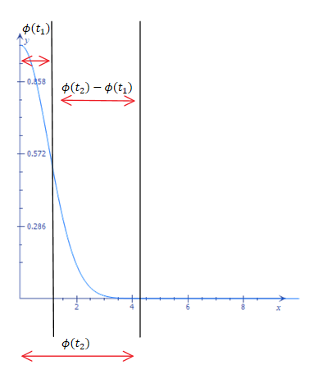
$$\left[\left(\int_{0}^{t_{2}}{e^{\frac{{-t}^{2}}{2}}dt}\right)-\left(\int_{0}^{t_{1}}{e^{\frac{t^{2}}{2}}dt}\right)\right]=\int_{t_{1}}^{t_{2}}{e^{-\frac{t^{2}}{2}}dt}$$

$$∴\frac{1}{2}\left[ϕ\left(t_{2}\right)-ϕ\left(t_{1}\right)\right]=\frac{1}{\sqrt{2π}}\int_{t_{1}}^{t_{2}}{e^{-\frac{t^{2}}{2}}dt}$$

